P3 Assignment: Data Visualization

By Dalton Anderson and Kevin Hitt

## **Reporting, Modeling and Storytelling**

Quantitative easing (QE) is a monetary policy tool central banks use to stimulate the economy and address recessions. Its primary objective is to combat economic downturns and prevent or mitigate recessions. Central banks increase the money supply and lower interest rates by purchasing government bonds and other financial assets. This liquidity injection aims to encourage lending, boost economic activity, and stabilize financial markets. QE can help mitigate recessions by providing liquidity during times of crisis, reducing borrowing costs, and promoting investment and consumption. Lower interest rates resulting from QE can incentivize borrowing, driving economic growth. However, the effectiveness of QE in preventing recessions and its long-term consequences are influenced by various factors, such as economic conditions, the scale and duration of the QE program, and the overall policy framework. It is an ongoing topic of debate and analysis among economists. Throughout the history of the US economy, there has been a recession at least every ten years except for after QE started. The critical question is, is QE preventing the inevitable while increasing inflation, or are the extra liquidity injections necessary to survive during globalization?

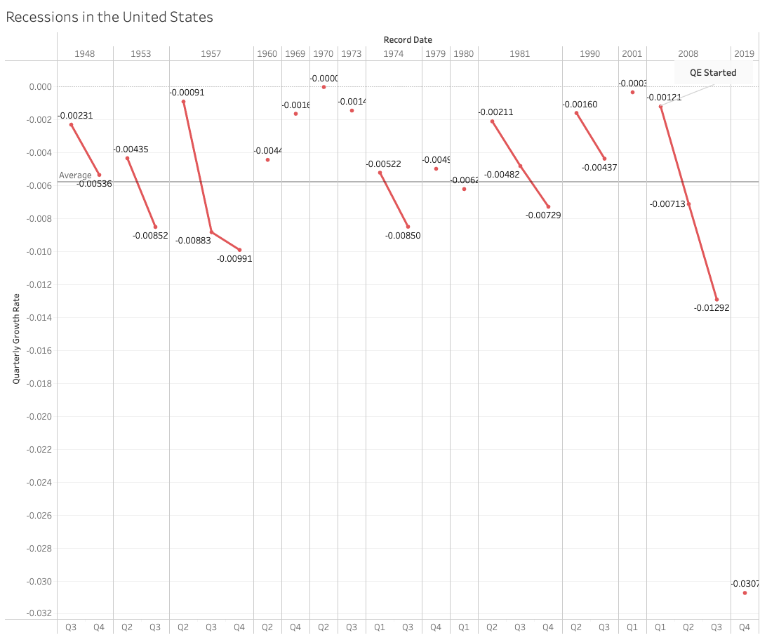

During economic recessions, the behavior of the unemployment rate reveals a distinct pattern where it tends to exhibit lagging characteristics. This means that the unemployment rate often reaches its highest point after the economy has already entered a downturn or during the early stages of the recovery phase. The reason behind this phenomenon lies in the response of businesses to changing economic conditions. When faced with a decline in demand, companies often strive to retain their existing workforce by minimizing layoffs. Consequently, the unemployment rate may only partially reflect the full extent of the economic downturn. As the recession progresses and economic conditions worsen, businesses may eventually reach a point where they can no longer sustain their current workforce. This leads to increased layoffs, resulting in a rising unemployment rate. Therefore, the unemployment rate peak tends to occur relatively later in the recessionary phase.

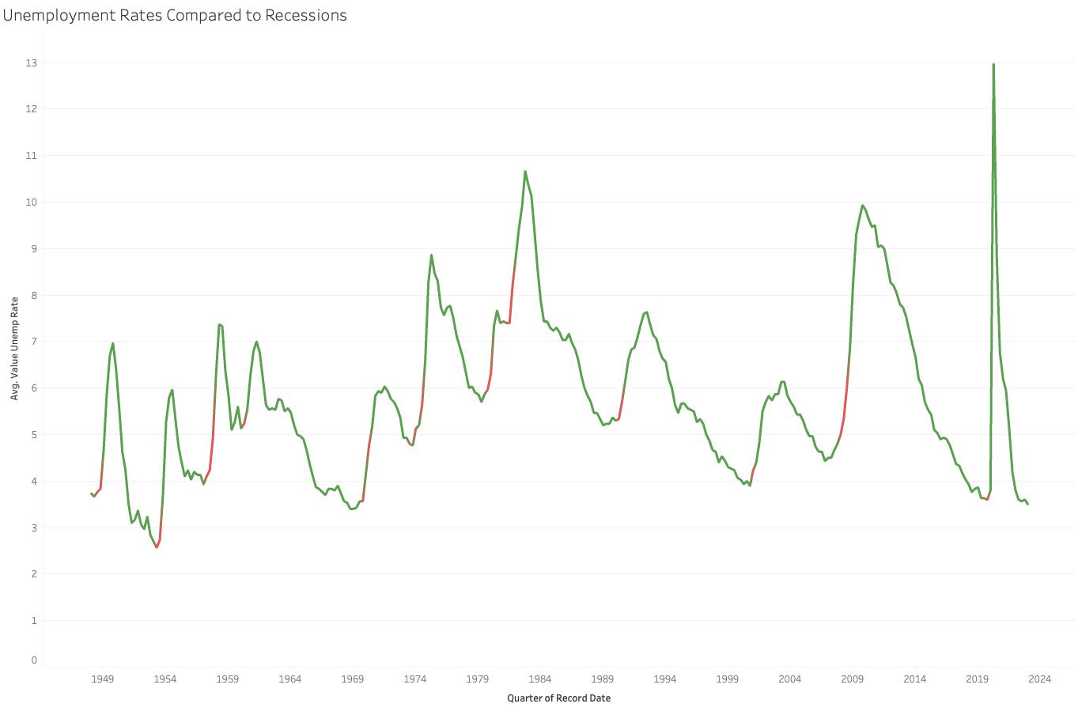

When the central bank engages in QE, it typically purchases government bonds and other financial assets from commercial banks and financial institutions. This process injects money into the economy to boost lending and spending. As a result, the federal debt can increase because the government is issuing more debt to finance its spending or to accommodate the central bank's purchases. The relationship between QE and the federal debt is complex. QE is often implemented as a response to an economic downturn or financial crisis, which can lead to decreased tax revenues and increased government spending on stimulus measures. These factors can independently contribute to higher levels of federal debt. The impact of QE on the federal debt depends on various factors, including the size and duration of the QE program, the pace of bond purchases, and the government's fiscal policies. If the economy recovers as intended, with increased economic activity and tax revenues, it can help mitigate the long-term impact on the federal debt.

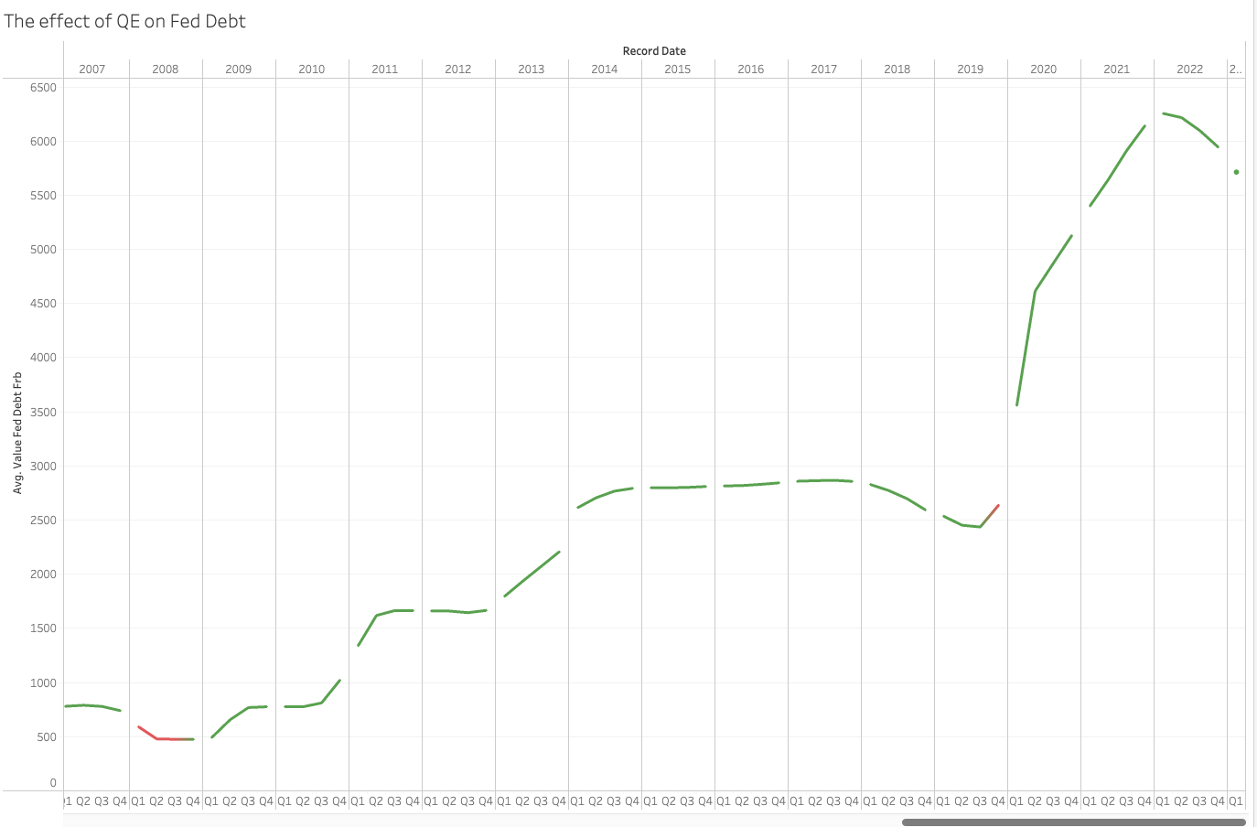

### ***Feature Selection***

Feature selection plays a crucial role in economic analysis, and when choosing variables to include in a model, several factors are considered. GDP, Febt Debt, and Unemployment rates are often selected as essential features due to their significance in understanding the overall economic landscape. Researchers and policymakers can fully understand the economic landscape by including GDP, Febt Debt, and Unemployment rates in economic analysis. These variables capture critical dimensions of economic performance, fiscal sustainability, and labor market dynamics. Their inclusion allows for a more nuanced analysis, providing insights into the interplay between economic growth, government debt, and employment trends, ultimately supporting informed decision-making and policy formulation.